**ALFABETO**

* **TENTE COPIAR**

|  |  |  |
| --- | --- | --- |
| **A** |  |  |
| **B** |  |  |
| **C** |  |  |

**C COMPLETE AS PALAVRAS:**

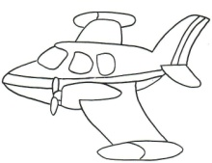

|  |  |  |  |  |
| --- | --- | --- | --- | --- |
|  | **V** |  |  |  |

|  |  |  |  |
| --- | --- | --- | --- |
| **B** |  | **L** |  |



|  |  |  |  |  |  |  |  |
| --- | --- | --- | --- | --- | --- | --- | --- |
| **C** |  | **C** | **H** |  | **R** | **R** |  |

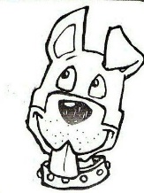

**AGORA, ESCREVA SEU NOME CONFORME ESTÁ ESCRITO NA TABELA DE ESTUDO:**

NOME:

DATA:______/______/2020

ALFABETO

* **TENTE COPIAR**

|  |  |  |
| --- | --- | --- |
| **D** |  |  |
| **E** |  |  |
| **F** |  |  |

COMPLETE COM AS VOGAIS OS NOMES DOS ANIMAIS: E DEPOIS PINTE O DESENHO COM CAPRICHO:

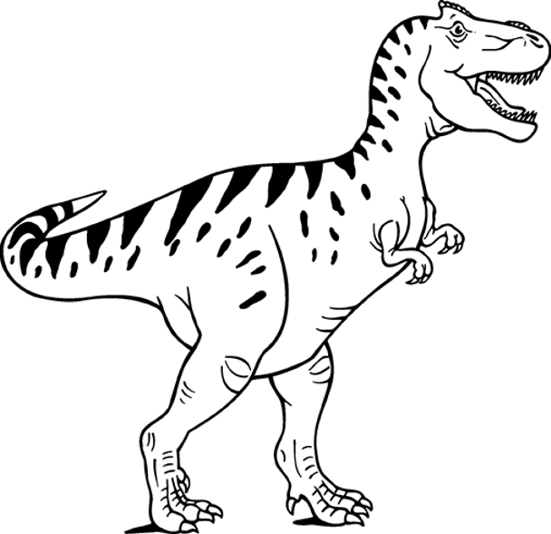

|  |  |  |  |  |  |  |  |  |  |
| --- | --- | --- | --- | --- | --- | --- | --- | --- | --- |
| **D** |  | **N** |  | **S** | **S** |  |  | **R** |  |

|  |  |  |  |  |  |  |  |
| --- | --- | --- | --- | --- | --- | --- | --- |
|  | **L** |  | **F** |  | **N** | **T** |  |

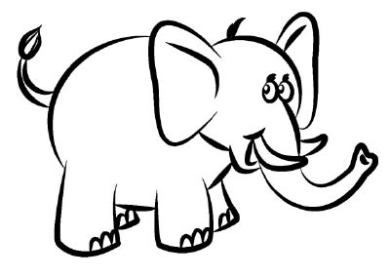

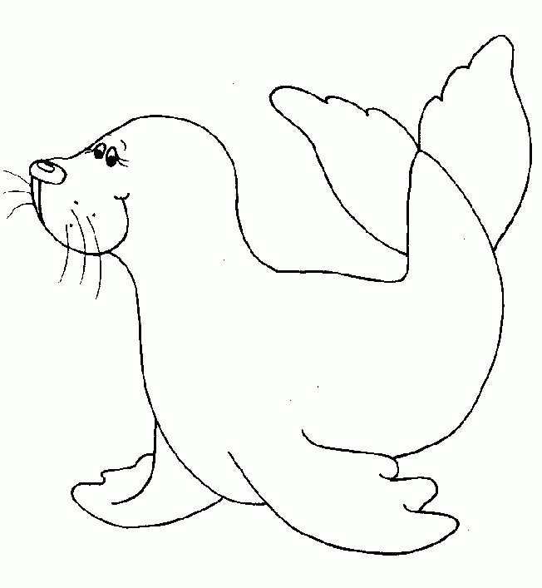

|  |  |  |  |
| --- | --- | --- | --- |
| **F** |  | **C** |  |

AGORA, ESCREVA SEU NOME

DATA:______/______/2020LIÇÃO DE CASA

* **TENTE COPIAR**ALFABETO

|  |  |  |
| --- | --- | --- |
| **G** |  |  |
| **H** |  |  |
| **I** |  |  |
| **J** |  |  |

COMPLETE AS PALAVRAS COM AS VOGAIS. E DEPOIS PINTE O DESENHO COM CAPRICHO:



|  |  |  |  |
| --- | --- | --- | --- |
| **G** |  | **T** |  |

COPIE

|  |  |  |  |  |  |  |  |  |  |
| --- | --- | --- | --- | --- | --- | --- | --- | --- | --- |
| **H** |  | **P** |  | **P** |  | **T** |  | **M** |  |





|  |  |  |  |  |  |
| --- | --- | --- | --- | --- | --- |
|  | **G** | **R** |  | **J** |  |

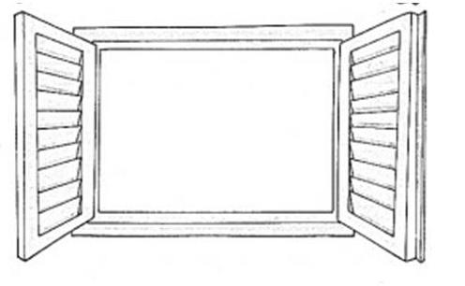

|  |  |  |  |  |  |
| --- | --- | --- | --- | --- | --- |
| **J** |  | **N** |  | **L** |  |

AGORA, ESCREVA SEU NOME

DATA:______/______/2020LIÇÃO DE CASA

* **TENTE COPIAR**ALFABETO

|  |  |  |
| --- | --- | --- |
| **K** |  |  |
| **L** |  |  |
| **M** |  |  |

COMPLETE AS PALAVRAS COM AS VOGAIS. E DEPOIS PINTE O DESENHO COM CAPRICHO:

|  |  |  |  |
| --- | --- | --- | --- |
| **K** |  | **W** |  |

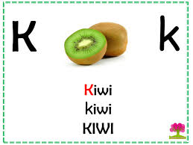

|  |  |  |
| --- | --- | --- |
| **L** |  |  |



|  |  |  |  |  |  |
| --- | --- | --- | --- | --- | --- |
| **M** |  | **C** |  | **C** |  |

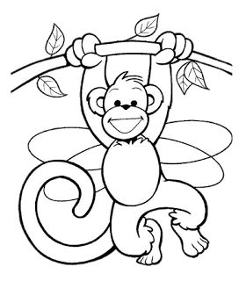

NOME:

DATA:______/______/2020LIÇÃO DE CASA

* **COPIE COPIAR** ALFABETO

|  |  |  |
| --- | --- | --- |
| **N** |  |  |
| **O** |  |  |
| **P** |  |  |
| **Q** |  |  |

COMPLETE AS PALAVRAS E DEPOIS PINTE O DESENHO COM CAPRICHO:

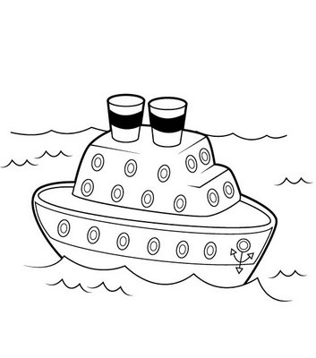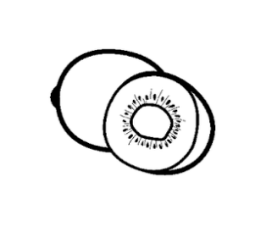

|  |  |  |  |  |
| --- | --- | --- | --- | --- |
| **N** |  | **V** |  |  |

|  |  |  |
| --- | --- | --- |
|  | **V** |  |

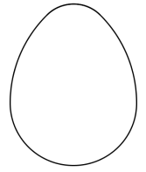

|  |  |  |  |  |  |  |  |
| --- | --- | --- | --- | --- | --- | --- | --- |
| **P** |  | **T** |  | **N** |  | **T** |  |



|  |  |  |  |  |  |
| --- | --- | --- | --- | --- | --- |
| **Q** |  |  |  | **J** |  |

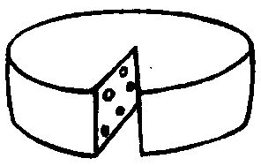

AGORA, ESCREVA SEU NOME IGUAL NA TABELA DE ESTUDOS:

DATA:______/______/2020 LIÇÃO DE CASA

* **TENTE COPIAR**ALFABETO

|  |  |  |
| --- | --- | --- |
| **R** |  |  |
| **S** |  |  |
| **T** |  |  |

COMPLETE AS PALAVRAS E DEPOIS PINTE O DESENHO COM CAPRICHO:

|  |  |  |  |
| --- | --- | --- | --- |
| **R** |  | **T** |  |



|  |  |  |  |
| --- | --- | --- | --- |
| **T** |  | **T** |  |

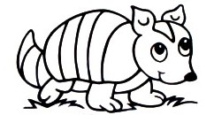

|  |  |  |  |
| --- | --- | --- | --- |
| **S** |  | **P** |  |



NOME:

DATA:______/______/2020 LIÇÃO DE CASA

* **TENTE COPIAR**ALFABETO

|  |  |  |
| --- | --- | --- |
| **U** |  |  |
| **V** |  |  |
| **W** |  |  |

COMPLETE AS PALAVRAS COM AS VOGAIS. DEPOIS PINTE O DESENHO COM CAPRICHO:

|  |  |  |
| --- | --- | --- |
|  | **V** |  |

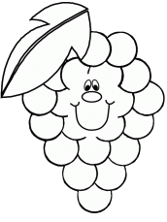

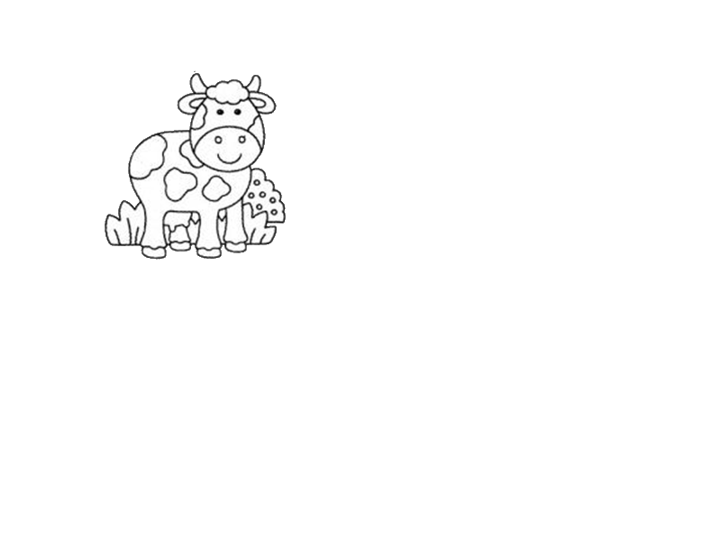

|  |  |  |  |
| --- | --- | --- | --- |
| **V** |  | **C** |  |

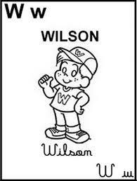

|  |  |  |  |  |  |
| --- | --- | --- | --- | --- | --- |
| **W** |  | **L** | **S** |  | **N** |

NOME:

DATA:______/______/2020 LIÇÃO DE CASA

* **TENTE COPIAR** ALFABETO

|  |  |  |  |
| --- | --- | --- | --- |
| **X** |  |  |  |
| **Y** |  |  |  |
| **Z** |  |  |  |

COMPLETE AS PALAVRAS COM AS VOGAIS. DEPOIS PINTE OS DESENHOS COM CAPRICHO:

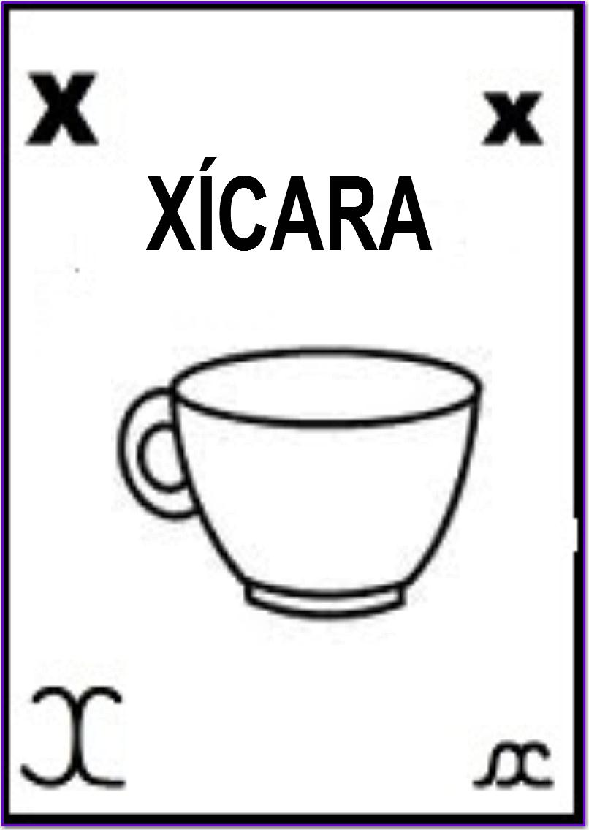

|  |  |  |  |  |  |
| --- | --- | --- | --- | --- | --- |
| **X** |  | **C** |  | **R** |  |

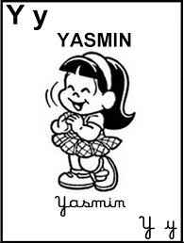

|  |  |  |  |  |  |
| --- | --- | --- | --- | --- | --- |
| **Y** |  | **S** | **M** |  | **N** |

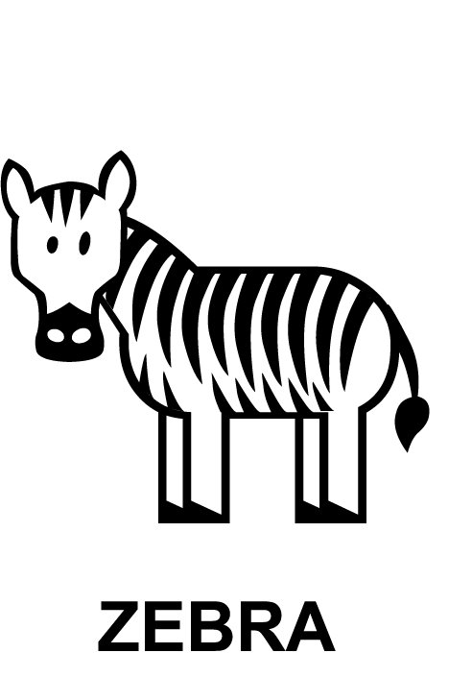

|  |  |  |  |  |
| --- | --- | --- | --- | --- |
| **Z** |  | **B** | **R** |  |

NOME:

DATA:______/______/2020 LIÇÃO DE CASA